Contents

Part I: Investigating the BI Job Market 2

Job #1: Senior Data Engineer (Business Intelligence) 2

Job #2: Business Analyst 3

Additional soft skills 4

Additional technical skills 5

Part II:  Investigating the TDWI web-site 6

Best Practices Report | What It Takes to Be Data Driven: Technologies and Best Practices for Becoming a Smarter Organization: BI ALL PPM ALL Best Practices Report What It Takes to Be Data Driven 6

Best Practices Report | Advanced Analytics: Moving Toward AI, Machine Learning, and Natural Language Processing 6

Best Practices Report | Accelerating the Path to Value with BI and Analytics 6

Best Practices Report | Data Lakes: Purposes, Practices, Patterns, and Platforms 6

Summary 7

Appendix 8

Investigating the World of BI

# Part I: Investigating the BI Job Market

## Job #1: Senior Data Engineer (Business Intelligence)

Would you like to become a part of the team which will help the Identity division of Azure Active Directory become data driven? Microsoft’s Identity division is at the center of Microsoft’s cloud strategy, providing authentication and authorization services that are used by the millions of Windows, Office, XBOX and Azure users worldwide. Our services handle over 4 million requests per minute from our data centers worldwide, collecting petabytes of high value telemetry data. Would you be willing to turn this data into actionable insights, and enable the business to reach into the future?

As a Senior Data Engineer, you will be responsible for defining and creating the data solutions empowering the entire Identity division. Working closely with embedded Data Scientists, you will play a pivotal role defining our data development roadmap and aligning with the Identity data strategy. This is a central role and essential in enabling data informed decisions. An appropriate candidate will have deep technical knowledge of BI systems design, big data architecture and technology landscape, service architecture, ETL/ELT orchestration, business intelligence tools such as Power BI as well as large scale event telemetry ingestion and aggregation systems. The candidate should have excellent organizational and communication skills and feel comfortable in a fast-paced environment.

So, if you are you an expert in designing and building business intelligence solutions, big data and are fascinated how analytics driven organizations can transform data into actionable insights, we have a dream job for you!

Key Responsibilities:

• Design, implement data solutions

• Define and execute the data engineering roadmap

• Provide technical leadership to the Identity Data, Experimentation, and Analytics team

• Lead the data engineering function

Operational Responsibilities:

• Contribute to the continual improvement of our data architecture

• Conduct code reviews ensuring development follows best practice

• Establish and maintain regular updates detailing current issues, cost, and development progress

• Direct research on potential technology solutions and implementations in support of new initiatives and opportunities.

Basic Qualifications:

• 5+ Years’ of software development experience

• 1+ Years of Big Data (Hadoop, MPP SQL, OR ETL/ELT) AND SQL

• BS in computer science or engineering

Preferred Qualifications:

• We are looking for a skilled and experienced Data Engineer with an extensive background in developing large scale data solutions

• Proven background and strong hands on experience with one or more of the following Big Data technology stacks: Hadoop/Cosmos in the cloud, MPP SQL, ETL/ELT orchestration systems

• The engineer will be highly experienced with relational databases (SQL Server or similar)

• The engineer will be highly experienced with MPP SQL such as Hive or ADW (or similar SQL implementations)

• Ability to effectively prioritize and execute tasks in a fast-paced environment

• Ability to express complex technical concepts effectively, both verbally and in writing

• Highly self-motivated, self-directed, and attentive to detail

• Strategic thinker, combined with strong ability to execute

• Solid verbal and written communication

• Experience implementing service-oriented architecture a plus

• Our processes include requirements analysis, continuous development cycle, integration with multi partner orgs and teams, enhancement, maintenance, testing, customer scenario evaluations and root cause analysis/resolution.

|  |  |
| --- | --- |
| Job # | 1085320 |
| Locations | United States, Redmond (WA) |
| Job families | Development (engineering) |
| Teams | Cloud and enterprise |

<https://careers.microsoft.com/jobdetails.aspx?ss=&pg=0&so=&rw=10&jid=342567&jlang=EN&pp=SS>

## Job #2: **Business** Analyst

Job ID: 604418 | Amazon Fulfillment Svcs, Inc.

DESCRIPTION

Alexa is the Amazon cloud service that powers Echo and Dot, the groundbreaking Amazon devices designed around your voice. Alexa’s Core Speech Experience team is responsible for unique approaches to improving the Alexa user experience. We create innovative metrics, conduct deep dive analyses, and bring insights to life with data visualization tools. Our analytics power collaboration with business and engineering teams to help prioritize system improvements.  
The successful person in this role has masterful attention to detail, and is adept at data insights and relationship-building. Through your special combination of technical and people skills, you will have a significant impact on the Alexa user experience. You will be the key liaison with Alexa partner teams (Entertainment, Information, Smart Home), while impacting the evolution of our analytics and tools approaches. You are a self-starter, comfortable with ambiguity in a fast-paced and ever-changing environment, and able to think big while paying careful attention to detail.  
Responsibilities include:  
· Develop intelligent, insightful reporting on Alexa user experience  
· Perform creative deep dive analyses to explain findings  
· Interact with internal stakeholders to share insights  
· Identify process and system improvement opportunities by monitoring existing metrics, analyzing data, and partnering with internal teams  
· Help drive instrumentation requirements as part of organization-wide programs and enhancements

BASIC QUALIFICATIONS

· Bachelor’s degree in Computer Science, Mathematics, Statistics, Finance, related technical field, or equivalent work experience.  
· 3-5 years of years of relevant work experience in analytics, data engineering, business intelligence, market research or related field, and 7-10 years professional experience (experience in consumer-facing industry preferred)  
· Experience gathering business requirements, using business intelligence tools to extract data, formulate metrics and build reports  
· Experience using SQL, ETL and databases in a business environment with large-scale, complex datasets  
· Experience with roles relying on effective oral and written communication with business and technical teams

PREFERRED QUALIFICATIONS

· Experience with data visualization using Tableau or similar tools  
· Proven track record of successful communication of analytical outcomes through written communication, including an ability to effectively communicate with both business and technical teams  
· Both technically deep and business savvy enough to interface with all levels and disciplines within the organization  
· Graduate degree in business, mathematics, statistics, economics, or other quantitative field  
· Experience with statistical modeling and analyzing large data sets  
· Experience with AWS technologies including Redshift, RDS, S3, EMR, EML

[https://www.amazon.jobs/en/jobs/604418/business-analyst](https://www.amazon.jobs/en/jobs/604418/business-analyst ))

## Additional soft skills

1. Communication
2. Teamwork
3. Adaptability/Flexibility
4. Problem Solving
5. Critical Thinking
6. Conflict Resolution
7. Leadership
8. Strong Work Ethics
9. Positive Attitude
10. Time Management Skills
11. Project Management Skill
12. Open to constructive criticism
13. Research skills
14. Facilitation
15. Relationship building
16. Self-Managing
17. Dealing with ambiguity

## Additional technical skills [1]

1. Analysis skills
2. Visual Modeling
3. Forecasting
4. Gap Analysis
5. Statistical Analysis
6. Process Mapping
7. Risk Assessment
8. Numerical skills
9. Programming (XML, JSON, Javscript)
10. Big Data anytics tookits (SparkSQL, SparkMLlib, Mahout)
11. Spreadsheet
12. Statistical Language (R, SAS, SPSS)

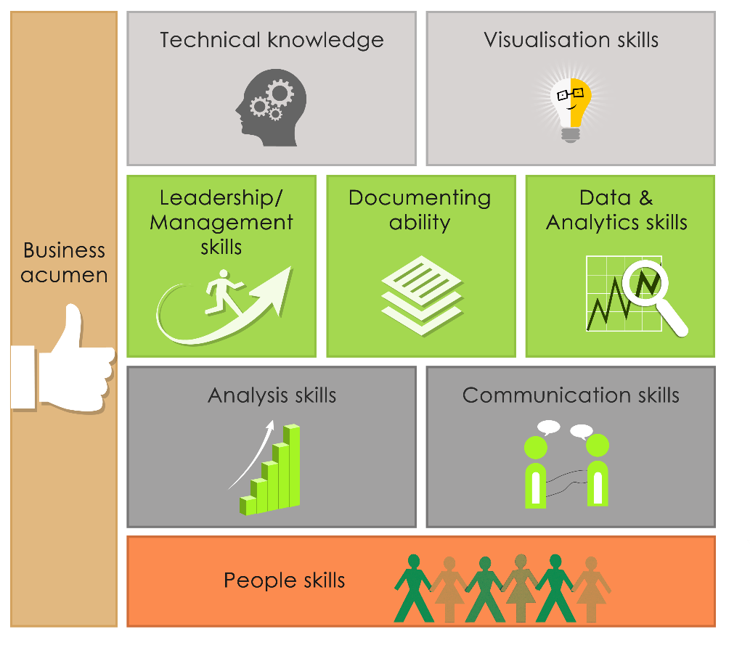

Figure 1 Business Analyst Skills

# Part II:  Investigating the TDWI web-site

The following is a list TDWI “Best Practice Reports” for 2017.

## [Best Practices Report | What It Takes to Be Data Driven: Technologies and Best Practices for Becoming a Smarter Organization: BI ALL PPM ALL Best Practices Report What It Takes to Be Data Driven](https://tdwi.org/~/media/11406FA6754F4B3AA1ACAB43251C8C85.pdf)

Release Date: 12.22.2017

This TDWI Best Practices Report examines how organizations become data-driven, including patterns for building out infrastructure for managing data and driving analytics. It also examines the best practices of those organizations that are data-driven across three areas we believe are important: technology, analytics, and organization.

## [Best Practices Report | Advanced Analytics: Moving Toward AI, Machine Learning, and Natural Language Processing](https://tdwi.org/research/2017/09/adv-all-best-practices-report-toward-ai-machine-learning-and-nlp/asset.aspx?tc=assetpg&tc=page0)

Release Date: 9.28.2017

There is a lot of excitement in the market about artificial intelligence (AI), machine learning (ML), and natural language processing (NLP). Although many of these technologies have been available for decades, new advancements in compute power along with new algorithmic developments are making these technologies more attractive to early adopter companies.

## [Best Practices Report | Accelerating the Path to Value with BI and Analytics](https://tdwi.org/~/media/2EFE1A7377A3401B867936B67CA5A558.pdf)

Release Date: 6.29.2017

This TDWI Best Practices Report focuses on current experiences with realizing value from BI and analytics and how organizations can accelerate the path to higher value.

## [Best Practices Report | Data Lakes: Purposes, Practices, Patterns, and Platforms](https://tdwi.org/research/2017/03/best-practices-report-data-lakes/asset.aspx?tc=assetpg&tc=page0)

Release Date: 3.29.2017

When designed well, a data lake is an effective data-driven design pattern for capturing a wide range of data types, both old and new, at large scale. By definition, a data lake is optimized for the quick ingestion of raw, detailed source data plus on-the-fly processing of such data for exploration, analytics, and operations. Even so, traditional, latent data practices are possible, too.

Organizations are adopting the data lake design pattern (whether on Hadoop or a relational database) because lakes provision the kind of raw data that users need for data exploration and discovery-oriented forms of advanced analytics. A data lake can also be a consolidation point for both new and traditional data, thereby enabling analytics correlations across all data.

## Summary

Dr. Halper asserted that many organizations that are early adopter are reaping the benefits from technologies such as artificial intelligence, machine learning and natural language processing to address various business goals to improve operational efficiencies and gain competitive advantage.

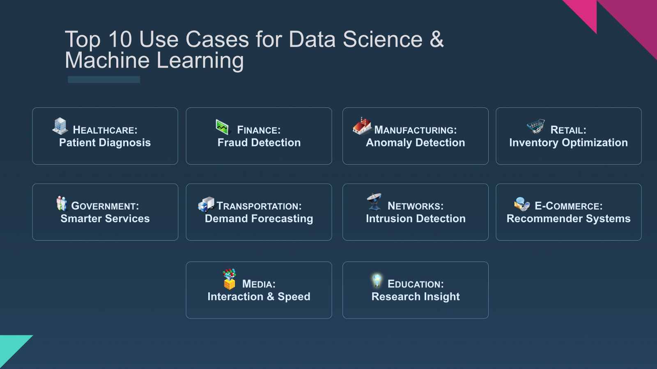

Figure 2 ML Uses Cases

Organizations in various industry are finding creative ways to use these technologies for traditional cases such as combat fraud, reduce risk, predict customer behavior just to name a few [2].

These early adopter organizations can reap the benefits and adapt through their digital transformation. Because qualified data analytics professionals are in great demand, early adopters have the advantage of hiring the brightest analytics experts to server in key roles such as data scientist and analytic leaders to chart the course.

The future is bright for people with analytical skills as we progressed through the 4th industrial revolution[3].

# Appendix

Executive Summary | Toward AI, Machine Learning, and Natural Language Processing

By Fern Halper, Ph.D.

10.3.2017

There is a lot of excitement in the market about artificial intelligence (AI), machine learning (ML), and natural language processing (NLP). Although many of these technologies have been available for decades, new advancements in compute power along with new algorithmic developments are making these technologies more attractive to early adopter companies. These organizations are embracing advanced analytics technologies for a number of reasons including improving operational efficiencies, better understanding behaviors, and gaining competitive advantage.

We have found that organizations are making use of these technologies in numerous ways. Some are applying machine learning for traditional use cases such as fraud and risk analysis or analyzing customer behavior. Others are using machine learning for preventive maintenance. Still others are building interactive chatbots and B2B applications that provide intelligence using a natural language interface. Deep learning is being employed to classify images and diagnose diseases. The use cases are wide and growing.

Data scientists are leading the way in terms of model building using various technology approaches. They are making use of open source analytics technologies such as R and Python as an important part of the advanced analytics efforts. Commercial analytics products are also being deployed by many, and some use open source in conjunction with commercial platforms. Organizations are also continuing to build out their data environments for analytics, with many beginning to utilize multiplatform data architectures.

Another important trend is that more AI technology approaches are targeting users beyond data scientists (e.g., a broad range of business users and “citizen” data scientists). Analytics applications more often include built-in AI/ML algorithms that are targeted to make it easier for business analysts and users to find insights. These include natural-language-based search interfaces, automated suggestions, and automated model building.

Early adopter experience provides clues as to best practices for those getting started with these technologies to gain advantage more quickly.

Early adopter experience provides clues as to best practices for those getting started with these technologies to gain advantage more quickly. For instance, early adopters are building centers of excellence (CoEs) and are hiring data scientists and analytics leaders. They are focused on data quality for analytics, operationalizing their analytics, and providing training opportunities. Overall, one thing is clear—organizations that are utilizing these technologies now are gaining value. In fact, early adopters are much more likely to be satisfied with their analytics deployments than those that are just getting started with more advanced analytics or those that have no plans. Organizations are also seeing value as they move through the analytics success cycle.

This TDWI Best Practices Report examines organizations’ experiences with and plans for machine learning, NLP, and AI, including technology plans as well as organizational strategies. It also looks at various advanced analytics challenges and how organizations are overcoming them. It examines the importance of new open source models and automated intelligence. Finally, it offers recommendations and best practices for successfully implementing more advanced analytics such as machine learning and AI in the organization.

*SAS, ThoughtSpot, Inc., and Vertica sponsored the research and writing of this report.*

About the Author

**Fern Halper**, **Ph.D.**, is vice president and senior director of TDWI Research for advanced analytics. She is well known in the analytics community, having been published hundreds of times on data mining and information technology over the past 20 years. Halper is also co-author of several Dummies books on cloud computing and big data. She focuses on advanced analytics, including predictive analytics, text and social media analysis, machine-learning, AI, cognitive computing and big data analytics approaches. She has been a partner at industry analyst firm Hurwitz & Associates and a lead data analyst for Bell Labs. Her Ph.D. is from Texas A&M University. You can reach her by email ([fhalper@tdwi.org](mailto:fhalper@tdwi.org)), on Twitter ([twitter.com/fhalper](http://twitter.com/fhalper)), and on LinkedIn ([linkedin.com/in/fbhalper](http://linkedin.com/in/fbhalper)).

1. http://www.texavi.com/blog/category/business-analysis
2. https://medium.com/inside-machine-learning/new-mental-models-for-machine-learning-part-1-7eaa7130fab
3. Schwab, K. (2016) The Fourth Industrial Revolution